**Personal Portfolio**

Group: 15

Michael Bell – n9487921

<https://bitbucket.org/ifb299group15/>

**Artifact 1** – ERD

**Description of the Artifact:**

In order to plan out the database for our website, I created an Entity Relationship Diagram (ERD). An ERD is a graphical representation of a system and shows the relationship between entities such as people, objects, places, and concepts. A copy of this diagram can be seen below. In this diagram a block represents an entity of our system and the lines connecting the blocks represent their relationship. For example, the student entity has a one-to-many relationship with the bookings entity which utilises the students ID (foreign key - FK); meaning a single student can have many bookings but a single booking cannot have many students (assuming the music school does not have group classes, in which case it would be a many-to-many relationship).



**Contribution to Project:**

This diagram allowed all the team members to have a visual reference as to how the different entities of our website would interact. This diagram is still being referred to as we add new features and continually update the database. This ERD has been through many iterations as we discovered potential flaws and improvements. The diagram shown is a representation of our current vision for the project and it may undergo further changes as required.

**Implementation:**

This diagram has been use to produce the current SQL database as shown below. The current database is still a work in progress and the entities/relationships are only being implemented when required. Whilst the SQL database is not complete, the correspondence to the ERD should be clear.



**Artifact 2** – UI Designs

**Description of the Artifact:**

One of my contributions to the design aspect of the sprints was the development of UI designs for various pages on the website. UI designs provide inspiration and targets for the development team and ensure that the client will be satisfied with the product being developed. The three UI designs I completed were on the account management, login, and dashboard page and are shown below:

Account Management:

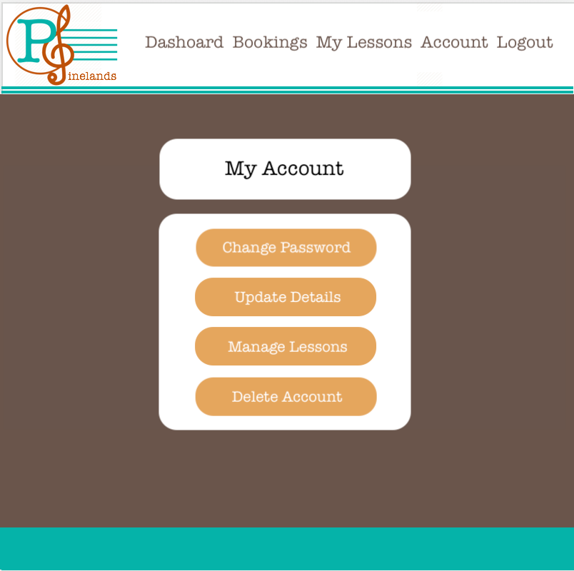

Login:

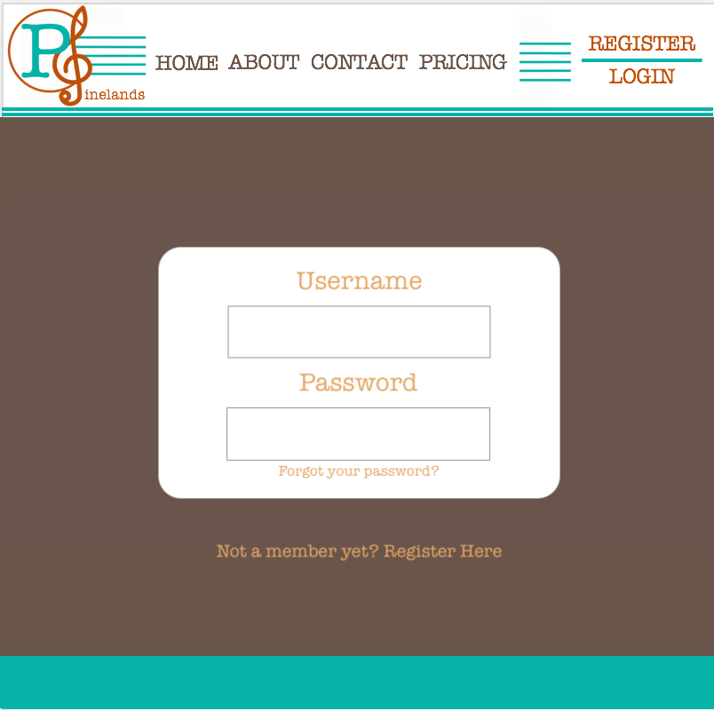

Dashboard:

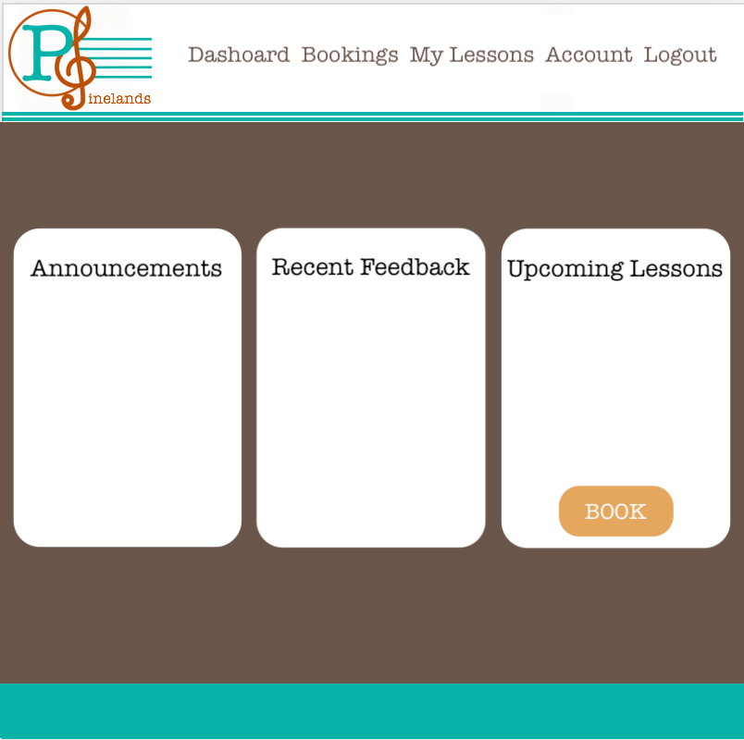

**Contribution to Project:**

These designs were used as a references during the development stages of the sprint. Having these design allowed the development team to quickly develop website pages to match this specification rather than trying to come up with designs during development. It also ensures pages across the website all share a common design theme.

**Implementation:**

Whilst the UI designs have had an influence during development, the development team has had a stronger focus on creating the functionality the website requires first. The current pages associated with these UI designs can be seen below. Once the functionality has been achieved, a stronger focus will be placed on meeting the UI design requirements.

Account Management:

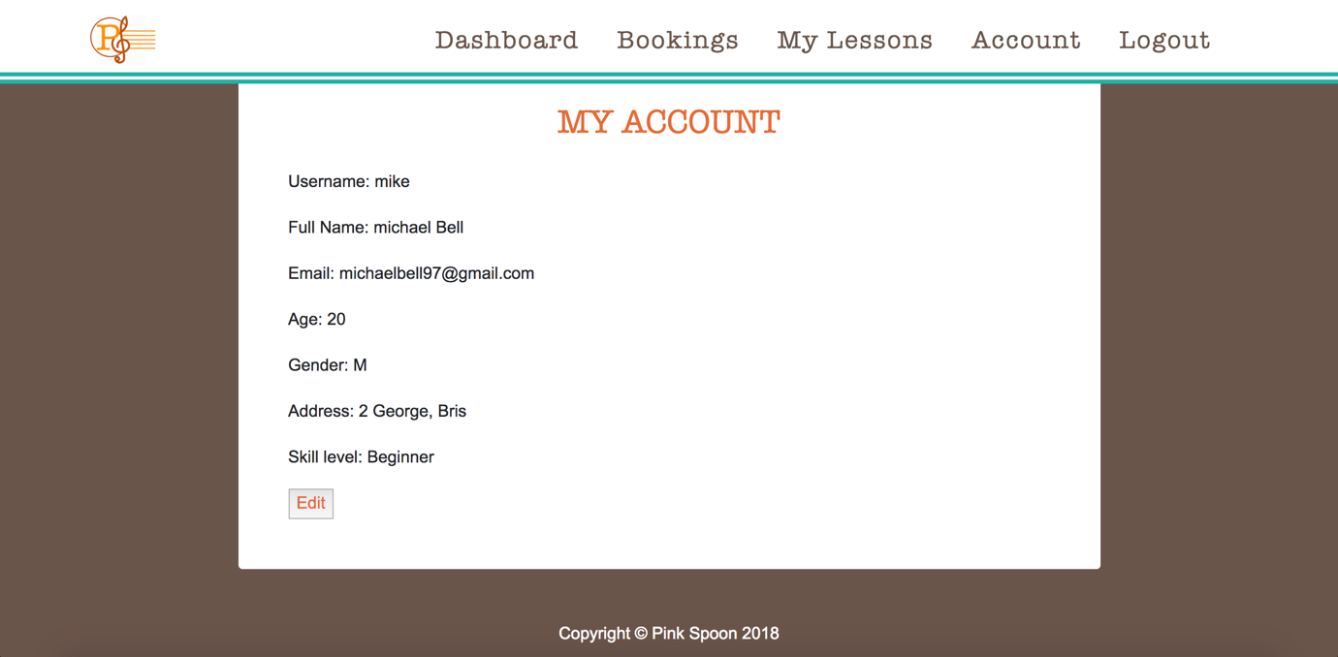

Login:

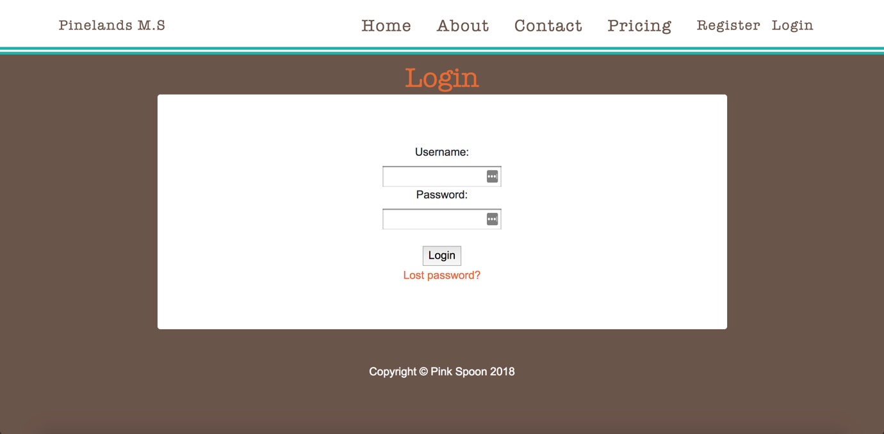

Dashboard:

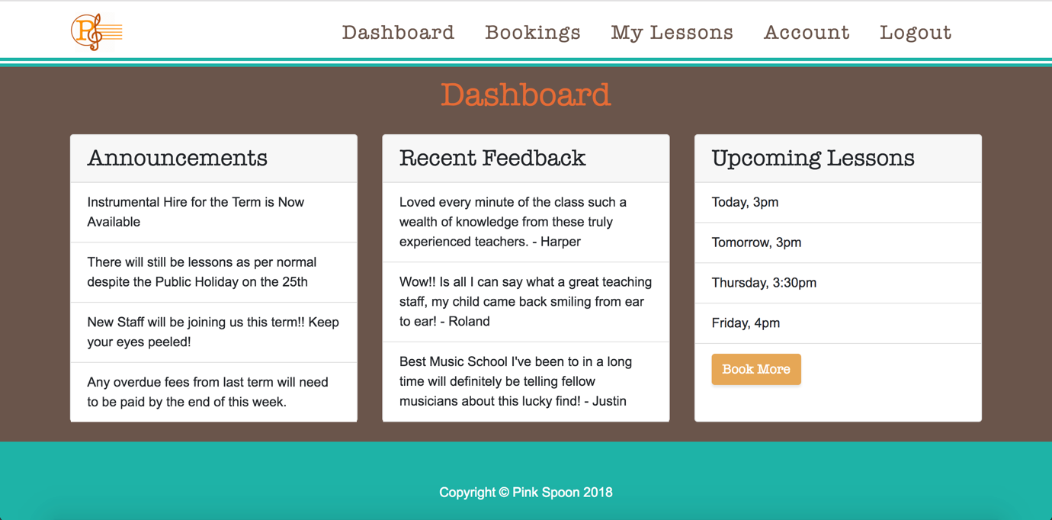

**Artifact 3** – Software Architecture Pattern

**Description of the Artifact:**

Another artifact of my contribution to the planning stage of the project was my research into which software architecture would be most suitable. Our team has chosen to implement our product based on a three-tier software architecture pattern. A three-tier software architecture is a client-server orientated system where the user interface, business logic, and data are maintained on separate platforms. The client layer is tasked with displaying relevant information to the user and handling any information the user provides. The business layer provides the relevant information to the client layer and processes any information received from the user through the client layer. The database layer simply completes requests for storage and retrieval of data. We have chosen this architecture due to its maintainability and security. Having a logical and physical separation of the different layers allows maintenance to be performed on a specific system without impacting the others, for example a change of business logic would not impact the presentation layer. Having the database stored on its own system allows for enhanced security and scalability. Whilst a two-tier system might be sufficient for a small music school, implementing a three tier system allows for easier scalability in the future.

**Contribution to Project:**

Researching which software architecture would be best created a foundation for the development of the website. By adhering to this architecture the development team has been able to provide a product that is both easily maintainable and scalable.

**Implementation:**

This chosen architecture improved our teams sprint velocity as it allowed members of our team to use various frameworks that they had prior experience and familiarity with. A summary of how we have implemented this architecture can be seen in the diagram below



**Artifact 4** – Website Implementation

**Description of the Artifact:**

Another of my major contributions to sprint one has been as a member of the development team. I have developed several website pages myself and assisted with various other areas of development.

**Contribution to Project:**

Whilst I have contribution to the development team on many different aspects of the product, some of my major contributions have been the development of the *dashboard* and *about us* pages on the website. These pages were developed to the clients UI specifications.

**Implementation:**

A screenshot of these pages in their current state can be seen below. The source code can also be found in the relevant artifact folder and the bitbucket link. As we progress through sprint 2 some changes will be made to the dashboard page and its interaction with the database.

Dashboard:



About us:

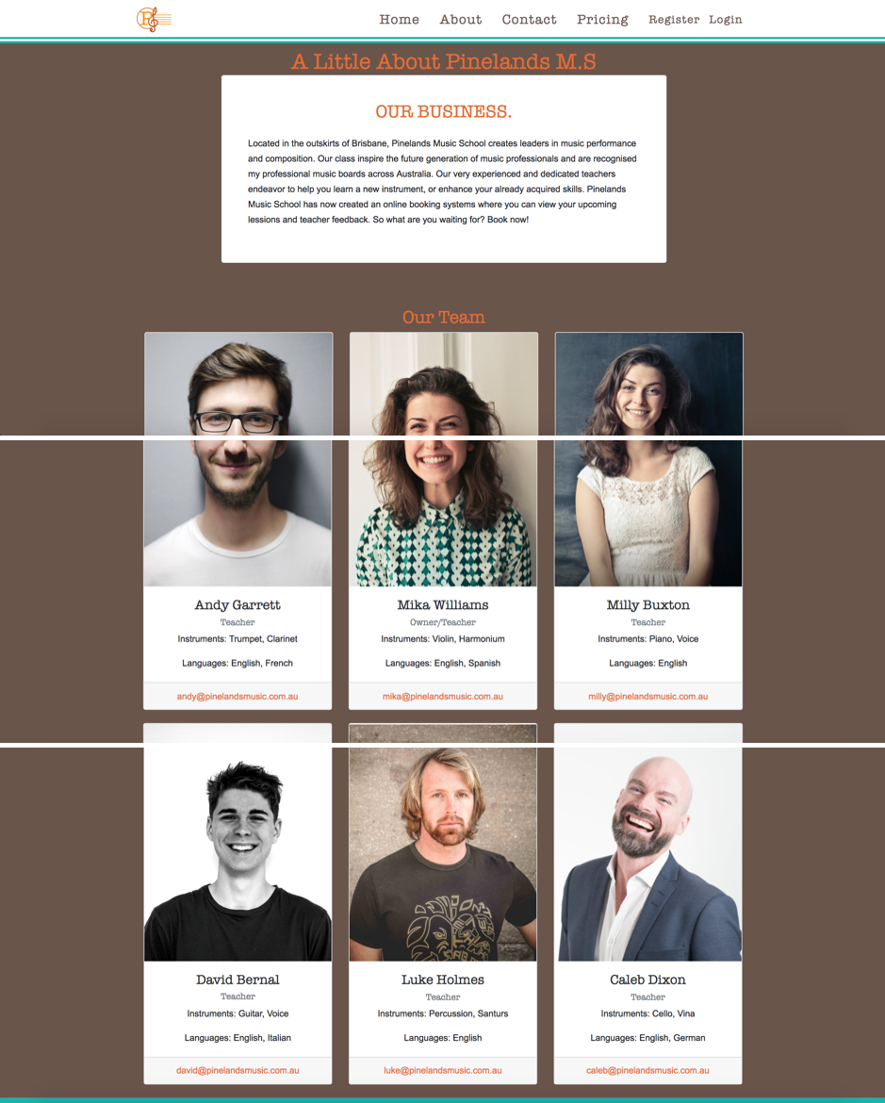

**Artifact 5** – Testing

**Description of the Artifact:**

Implementing new features into websites can sometimes create unwanted side effects that can often go unnoticed without a proper system in place. Having a set of test cases that can be performed each time a significant new feature is added allows the development team to easily to quickly notice when issues arise. To achieve this, I have developed a test case spreadsheet.

**Contribution to Project:**

To ensure the development team was able to regularly test the functionality of the website, I created a spreadsheet with various testing criteria that could be checked whenever new features were implemented. This spreadsheet could be used as a reference should we decide to implement automated testing into the website at a later stage. Other members of the team have made contributions to this spreadsheet.

**Implementation:**

A complete copy of the spreadsheet in its current form can be found in the artifact folder. An example of some of the entries are shown below:

